

Bilkent

Department of Computer Engineering

CS 319 (Object –Oriented Software)

Engineering Project

**Final Report**

*QuantumChess*

16.12.2017

Section 02

* Rubin Daija
* Serhat Bezmez
* Kaan Akturk
* Mastan Abdulkhaligli

Instructor

* Bora Gungoren
  1. **System Requirements**

The standart Java Runtime Environment (JRE) must be installed before installing game.

**Minimum system requirements:**

* Windows XP or higher OS
* 256 MB of RAM or higher
* Screen resolution 800*600

**Recommended system requirements:**

* 512 MB RAM or higher
* Screen resolution 1024*768
* Supported Chipsets: NVIDIA-GeForce...
  1. **Installations:**
* Player can execute the game (recommended method)
* If player wants some change in game he/she can run code in java and can play the game.

**2.1 Game Screenshots and Menus**

***2.1.1 Main Page***

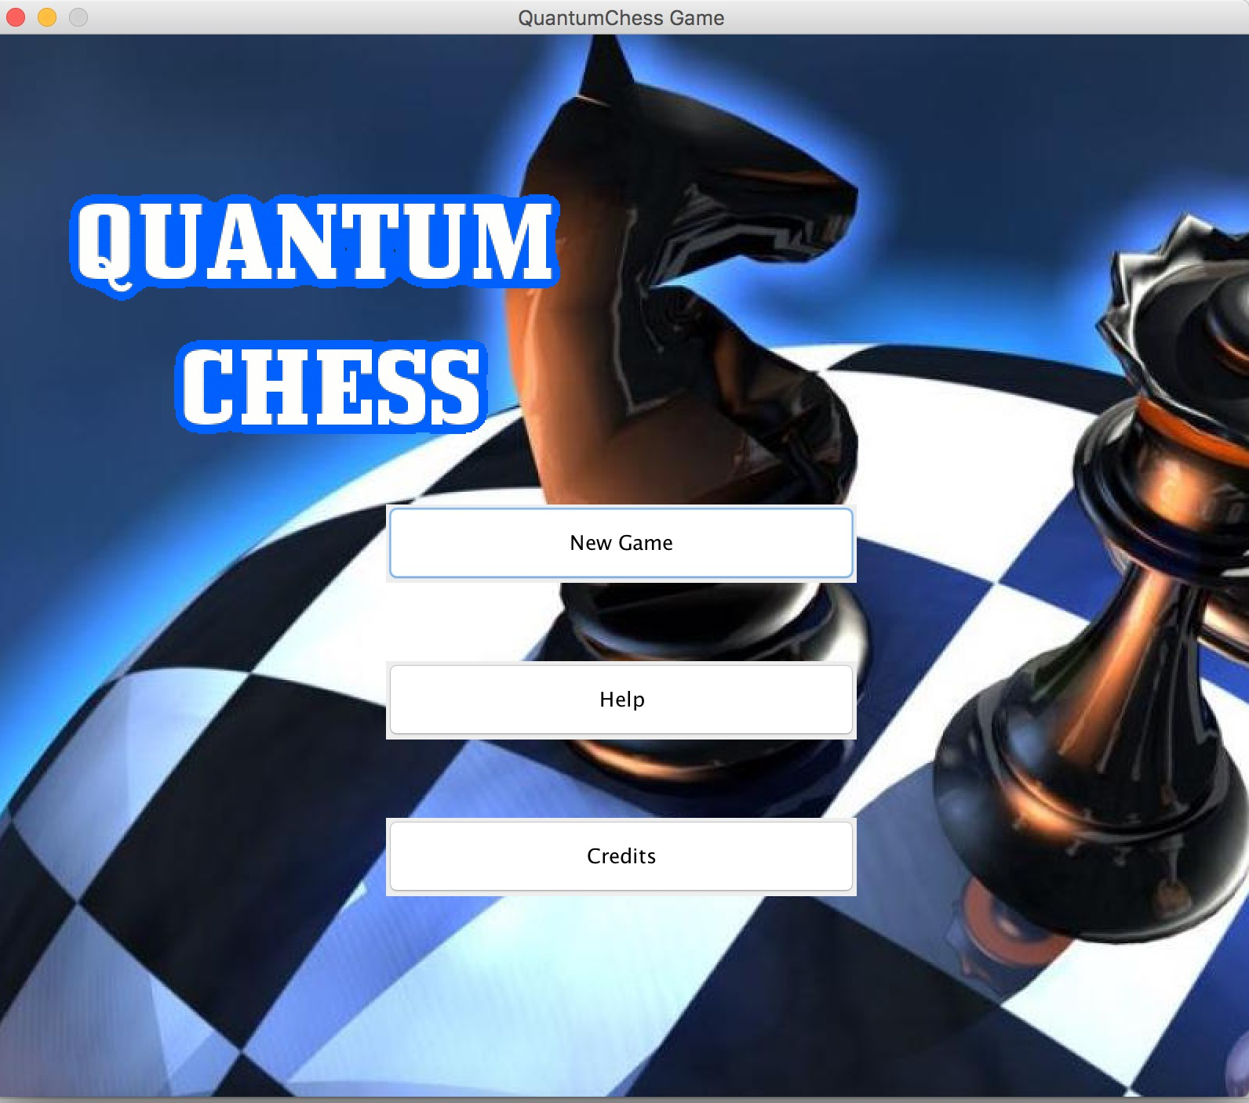

This is the main page of QuantumChess game. After clicking New Game button,the game will start and players can play with each other.

***2.1.2 Credits Page***

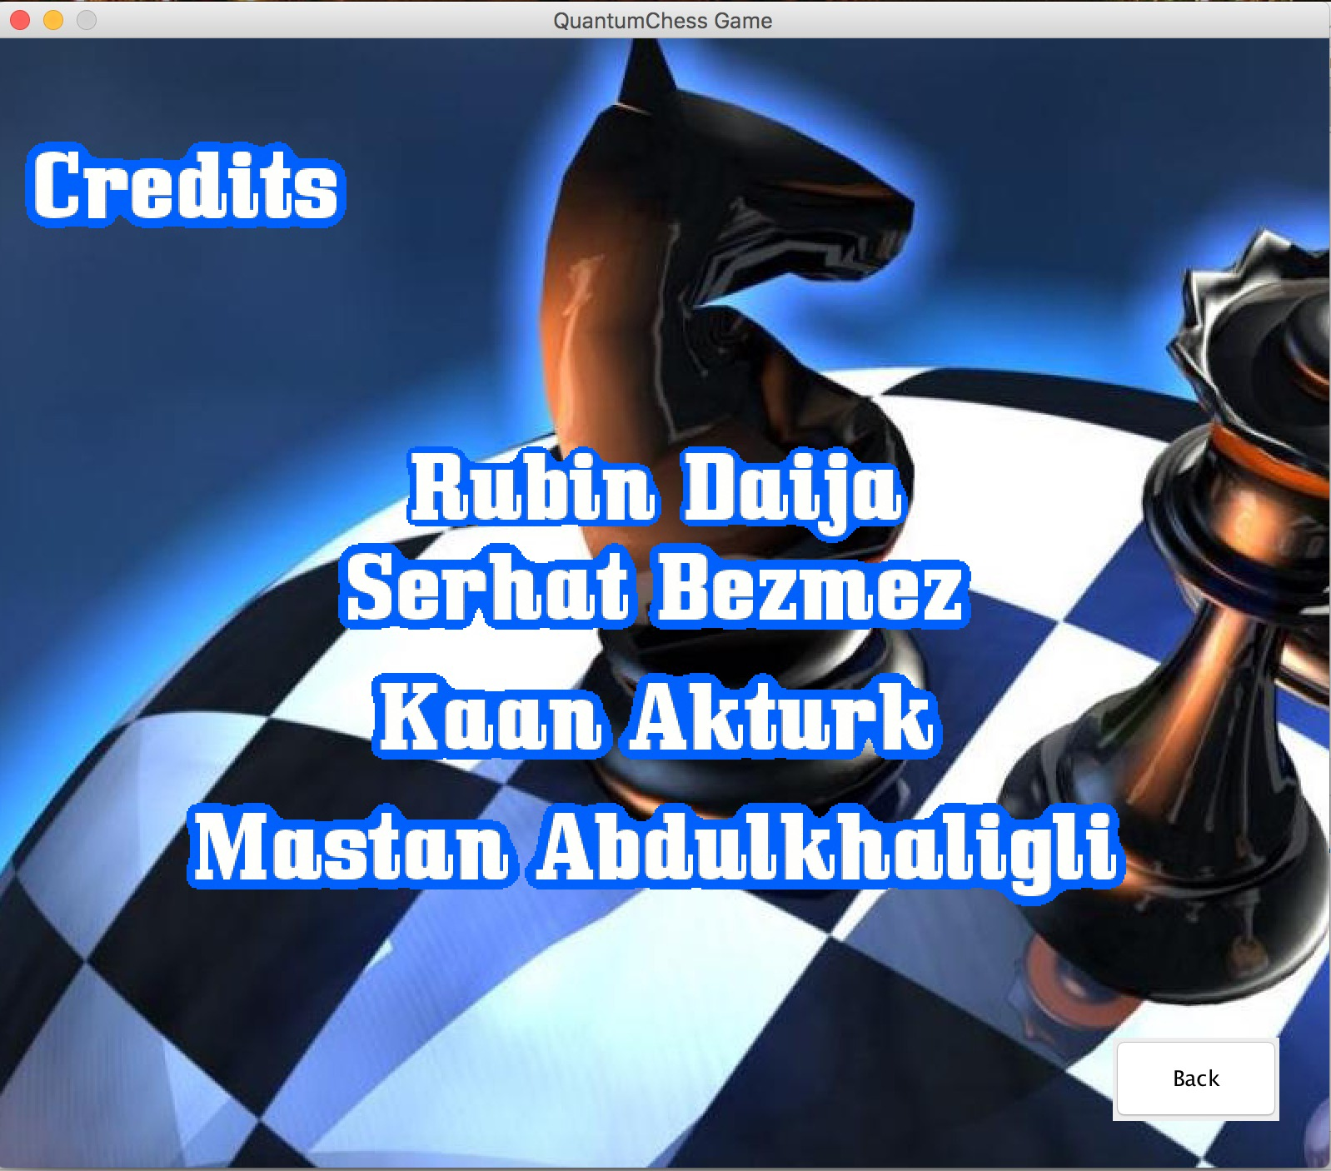

If players are curious about developers of QuantumChess game he/she can click “Credits” and learn about devolepers. When player want to back to the main menu player should push “Back” button

***2.1.3 Game***

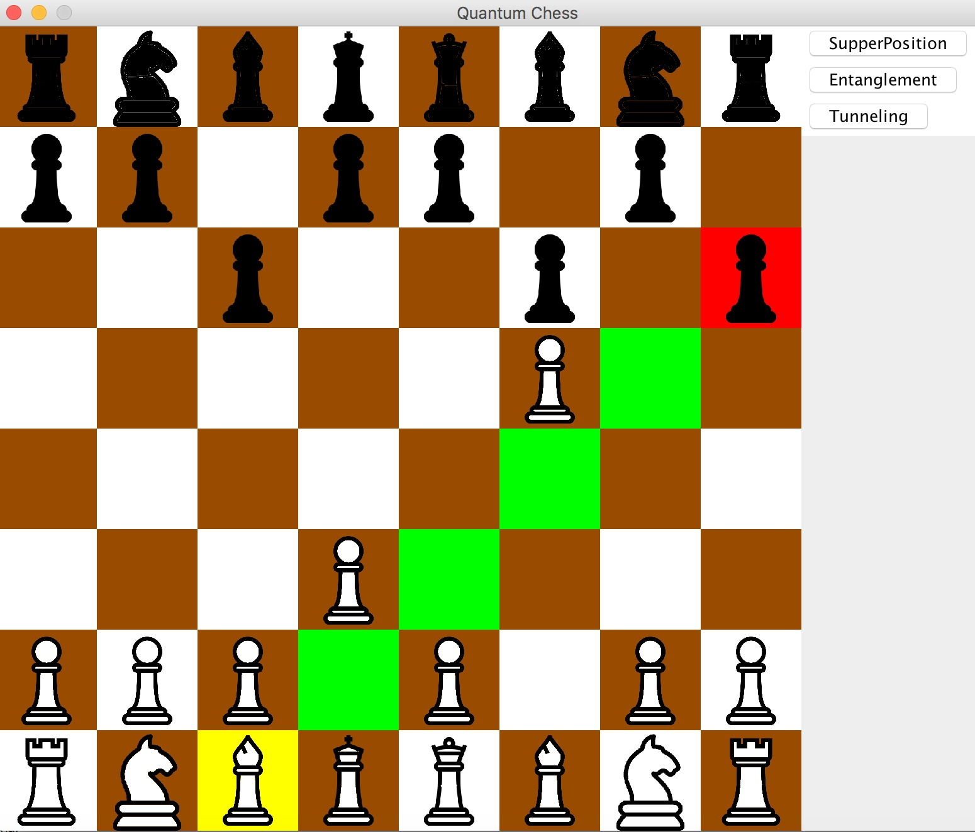

This is a view of Game. There are three buttons which are “SuperPosition”,”Entanglement” and “Tunneling” power ups.